Nut Swamp Park  Middletown Township (N.J.)  ADA Transition Plan
Gordon & Orchard Spring 2008
S
Location | Identified Barrier(s) | Recommended Corrective Action  Based on ADAAG or Applicable Guideline | Priority:  L=Low  M=Medium  H=High | *Cost Estimate | Barrier Removal Target Date & Notes
EXTERIOR FEATURES
Parking | Two spaces are signed as accessible but no “van accessible” designation exists. Signs are mounted too low. Accessible spaces and access aisles are not striped | At least 1 accessible space shall be designated as “van accessible” and be served with an access aisle at least 96” wide. Spaces shall be at least 96” wide. Two spaces may share a common access aisle. Signs shall be located so they cannot be obscured by a vehicle parked in the space (4.1.2(5)(b) & 4.6.4). | H | $1,000
Accessible Paths of Travel | The route to the ball field, football field and playground is rough and uneven grass. | At least one accessible route shall connect accessible buildings, facilities, elements, and spaces that are on the same site. Ground and floor surfaces along accessible routes shall be stable, firm, slip-resistant and free of abrupt changes in level (4.3.2). | M+ | $8,500
Play Ground | The play equipment surface is engineered wood chips. | Recommendation: this material has been generally accepted as “ADA compliant”, however, to maintain an adequate firm and level surface free of thresholds, this surface must be constantly maintained. We recommend using a rubber or corked surface. There are no ADA enforceable standards for playground areas, only guidelines at the present time; however, program access must still be met. | L+ | $3,000
Ball Field | No designated wheelchair seating exists at the bleacher seating. | Recommendation: designate at least one location as wheelchair accessible seating. Ensure that the location provides an unobstructed line of sight. The designated wheelchair seating area should be large enough for at least 1 wheelchair user and 1 companion. A 60” by 60” minimum area would be preferred. Designation could be accomplished by painting the universal symbol of access on the pavement. | M | $1,000
Concessions Area | Concessions counter is 38” high.  Picnic tables have 12” knee clearance depth.  Women’s Restroom:  - Signage is mounted on door  - A 1” threshold exists at the entrance door   - The sink has 27 ½” knee clearance to apron.  - The toilet flush control is located on the far side of toilet.  Men’s Restroom:  - Signage is mounted on the door.  Note: there was no access to the interior as staff could not locate the correct key. | Transaction counters shall have a 36” maximum height, 36” minimum length. Equivalent facilitation might consist of a folding shelf attached to the main counter on which an individual with disabilities can write (7.2).  At least one shall have 19” minimum depth (4.32.3).  Mounting height shall be 60’ above the finish floor to the centerline of the sign on the wall adjacent to the latch side of the door (4.30.6).  Thresholds at doorways shall not exceed ½” beveled (4.13.8).  Lavatories shall provide a clearance of at least 29” above the finish floor to the bottom of the apron (4.19.2).  Flush controls shall be mounted on the wide side of toilet areas (4.16.5).  Mounting height shall be 60’ above the finish floor to the centerline of the sign on the wall adjacent to the latch side of the door (4.30.6). | L+  L  M+  M+  L  L  M+ | $500  $400  $50  $200  $225  $300  $50

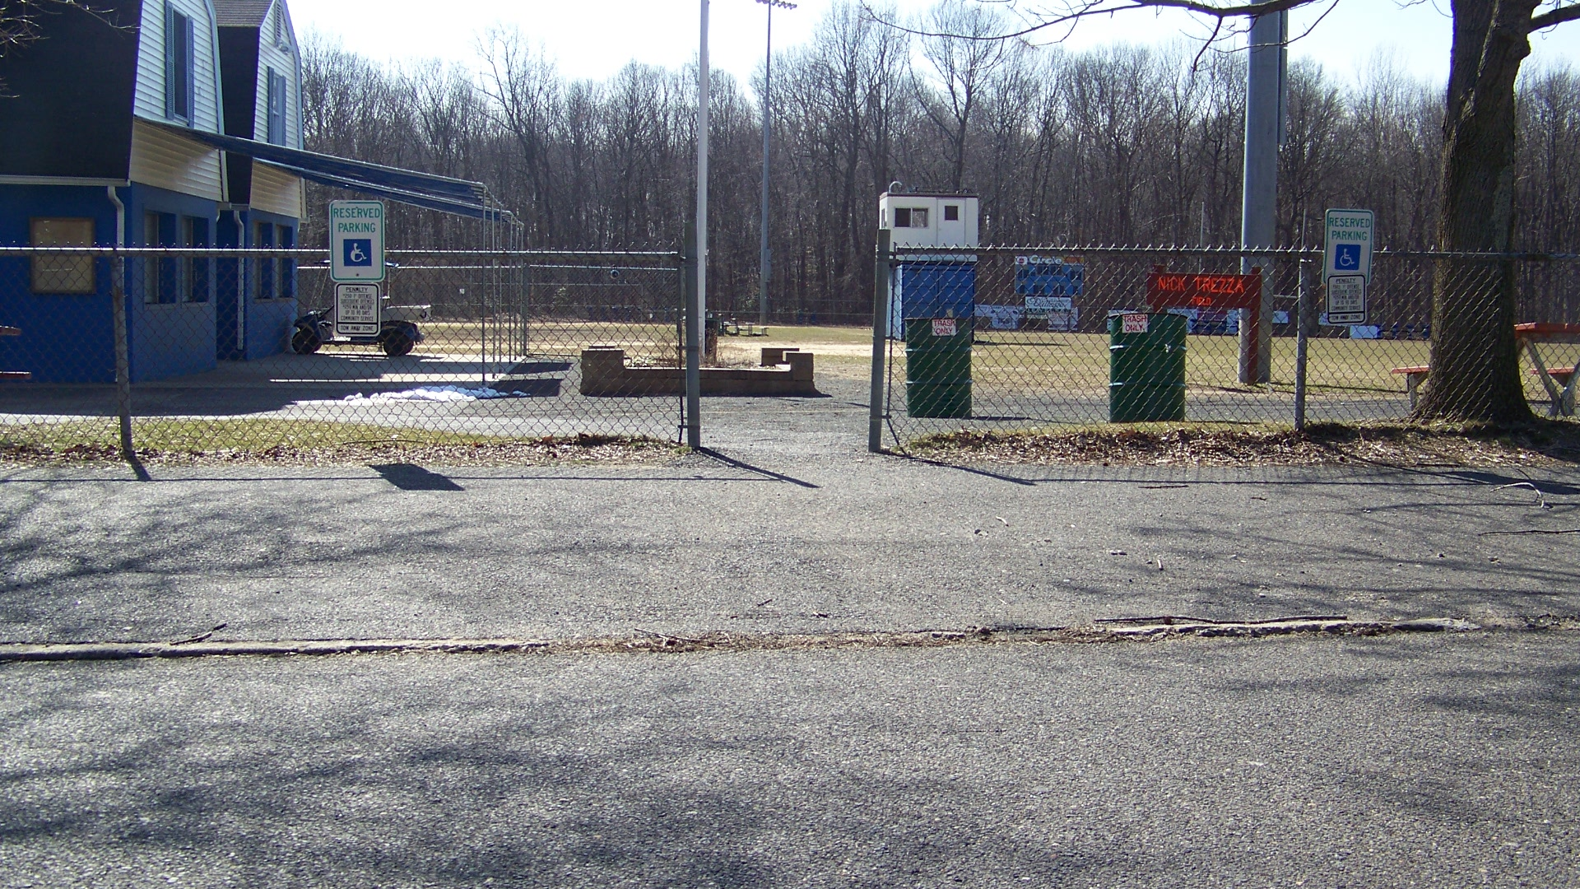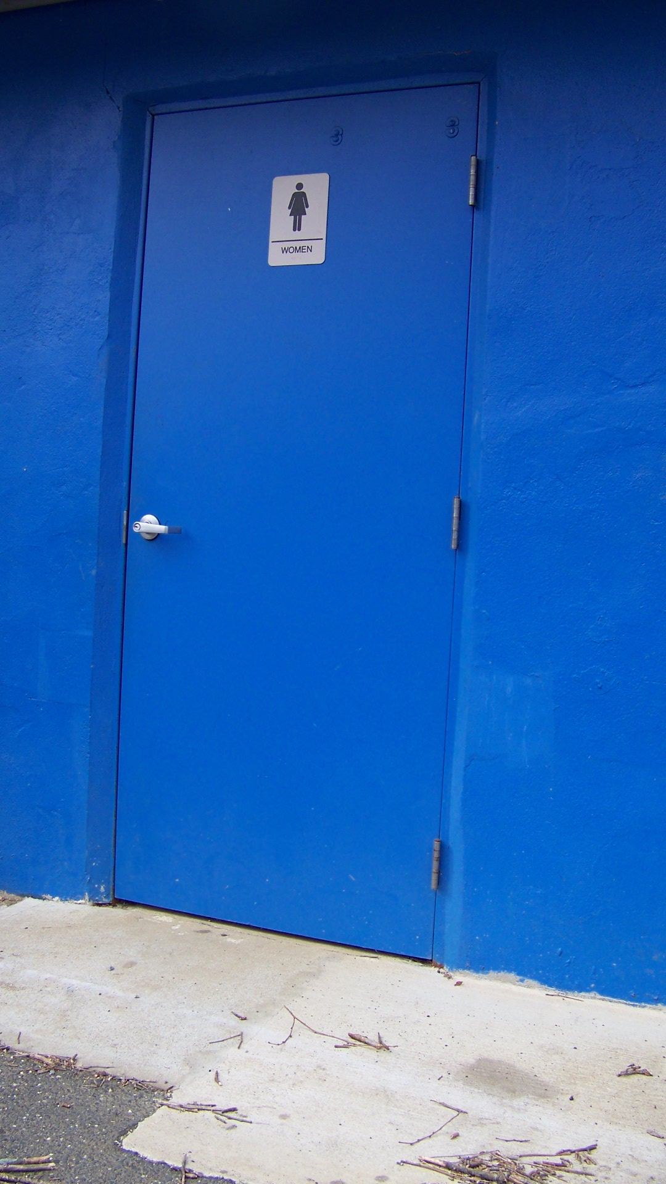
Accessible parking spaces and access aisles are not Restroom signs are mounted in
striped. Signs are mounted too low. incorrect locations.

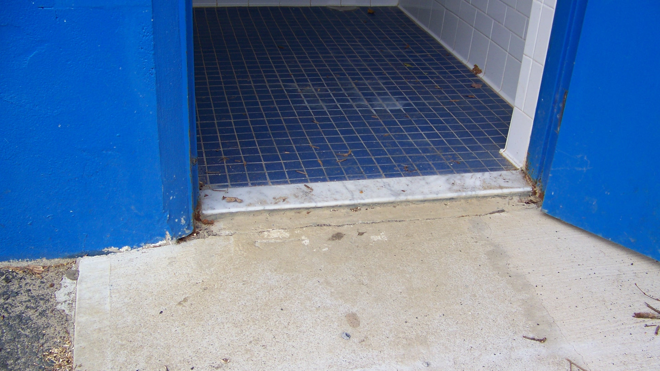
Restroom entrances have excessive thresholds.

Priority Level | Cost Estimate Totals
Low’s | $4,425
Medium’s | $9,800
High’s | $1,000
TOTAL | $15,225.00*

* Cost estimates are given as general guidance only. Actual construction costs will vary depending on availability of materials and contractors used and the type of barrier removal utilized.

