Normandy Park  Middletown Township (N.J.)  ADA Transition Plan
Nutswamp & Normandy Roads Spring 2008
Location | Identified Barrier(s) | Recommended Corrective Action  Based on ADAAG or Applicable Guideline | Priority:  L=Low  M=Medium  H=High | *Cost Estimate | Barrier Removal Target Date & Notes
EXTERIOR FEATURES
Parking | Three spaces are designated as accessible but none have “van accessible” signage. Access aisles are 60” wide. | At least 1 accessible space shall be designated as “van accessible” and be served with an access aisle at least 96” wide. Access aisles serving standard accessible spaces shall be at least 60” wide. Two spaces may share a common access aisle (4.1.2(5) & 4.6.4). | H | $500
Accessible Paths of Travel | The route to the hockey rink has a sloped area where the handrails are 40” to the top, 3” in diameter and lack extensions  The route to the ball field is rough and uneven grass. | Top of handrail gripping surfaces shall be mounted between 34” to 38” above ramped surfaces. The diameter or width of the gripping surfaces of a handrail or grab bar shall be 1 ¼” to 1 ½”. If handrails are not continuous, they shall extend at least 12” beyond the top and bottom of the ramped segment and shall be parallel with the floor or ground surface (4.8.5 & 4.26).  At least one accessible route shall connect accessible buildings, facilities, elements, and spaces that are on the same site. Ground and floor surfaces along accessible routes shall be stable, firm, slip-resistant and free of abrupt changes in level (4.3.2(2) & 4.5.1). | M+  M- | $750  $2,500
Hockey Rink | Players dugouts have 4” steps.  No designated wheelchair seating exists at the bleacher seating. Rink fences are eye level for wheelchair users. | Changes in level up to ¼” may be vertical and without edge treatment. Changes in level between ¼” and ½” shall be beveled with a slope no greater than 1:2. Changes in level greater than ½” shall be accomplished by means of a ramp (4.5.2).  Recommendation: designate at least one location on each side of the score keepers box. Each designated wheelchair seating area should be large enough for 1 wheelchair user and 1 companion. A 60” by 60” minimum area would be preferred. Designation should be accomplished by painting the universal symbol of access on the pavement. To ensure that these locations offer the patron a line of sight, they should be located directly behind the fence. Due to the fence height, we recommend either modifying the fence to a lowered height at each 60” by 60” location or raise the floor surface at each location to provide an unobstructed view. | L  M+ | $500  $2,000
Ball Field | No designated wheelchair seating exists at the bleacher seating. | Recommendation: designate at least one location as wheelchair accessible seating. Ensure that the location provides an unobstructed line of sight. The designated wheelchair seating area should be large enough for at least 1 wheelchair user and 1 companion. A 60” by 60” minimum area would be preferred. Designation could be accomplished by painting the universal symbol of access on the pavement. | M | $1,000
Tennis Courts | A 2” threshold exists at court entrance. | Thresholds at doorways shall not exceed ½” beveled (4.13.8). | M | $200
Play Ground | The surface is engineered wood fiber. | Recommendation: this material has been generally accepted as “ADA compliant”, however, to maintain an adequate firm and level surface free of thresholds, this surface must be constantly maintained. We recommend using a rubber or corked surface. There are no ADA enforceable standards for playground areas, only guidelines at the present time, however, program access must still be met. | L | $3,000

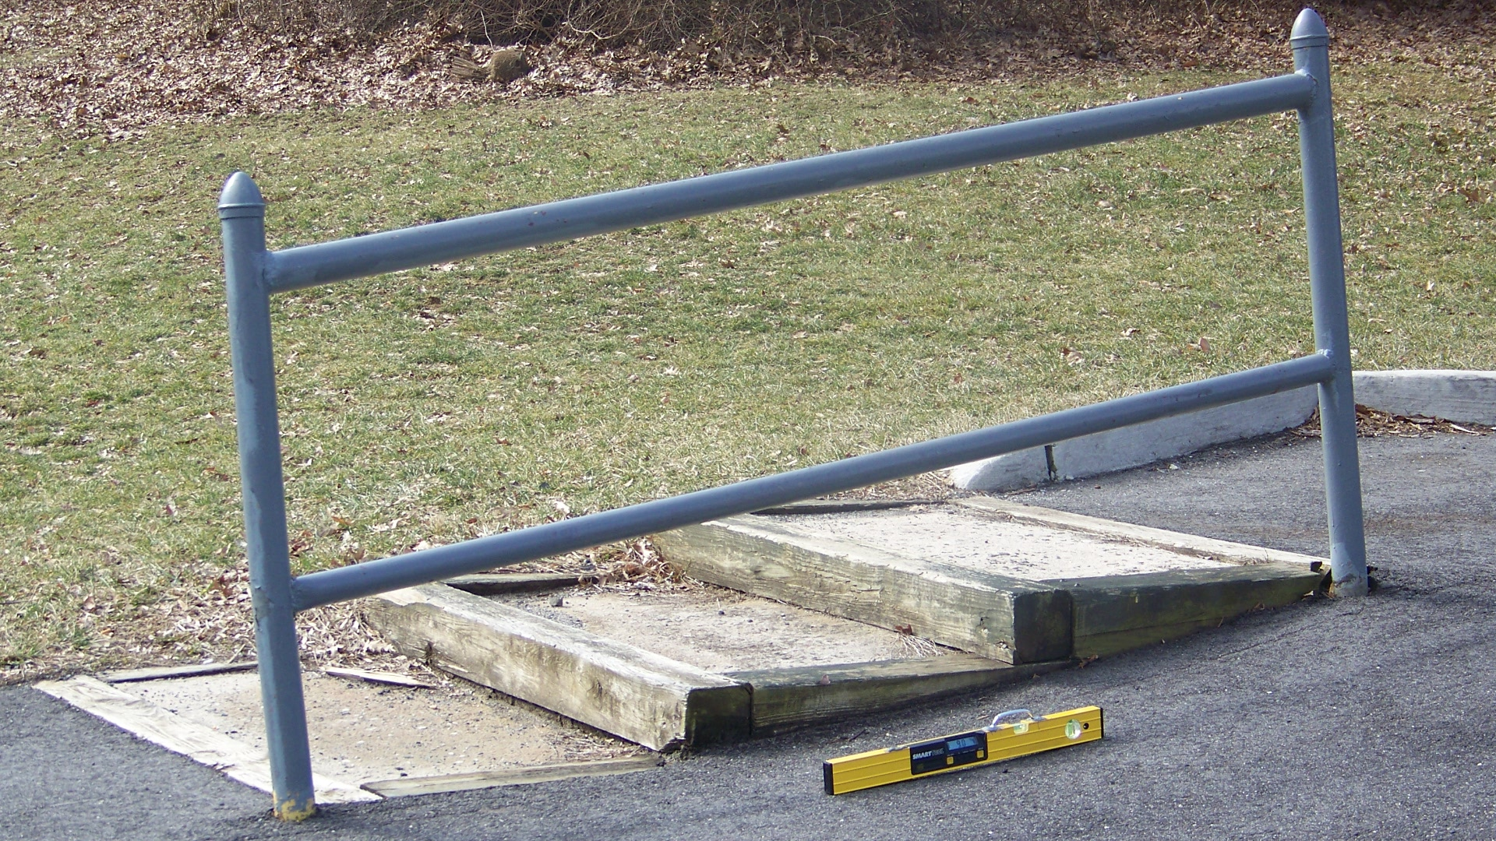
These handrails near the hockey rink are mounted too
high, have too large of a diameter and lack adequate
extensions.

Priority Level | Cost Estimate Totals
Low’s | $3,500
Medium’s | $6,450
High’s | $500
TOTAL | $10,450.00*

* Cost estimates are given as general guidance only. Actual construction costs will vary depending on availability of materials and contractors used and the type of barrier removal utilized.

