McMahon Park  Middletown Township (N.J.)  ADA Transition Plan
Atlantic Ave. Spring 2008
Location | Identified Barrier(s) | Recommended Corrective Action  Based on ADAAG or Applicable Guideline | Priority:  L=Low  M=Medium  H=High | *Cost Estimate | Barrier Removal Target Date & Notes
EXTERIOR FEATURES
Parking | No designated accessible parking exists near the restrooms and play area (lot has 55 total spaces).  No designated accessible parking exists near the hockey rink (lot has 37 total spaces). | Minimum 1 “van accessible” space and 2 standard accessible spaces. Access aisles serving van spaces shall be at least 96” wide and aisles serving standard accessible spaces shall be at least 60” wide. Signs shall be located so they cannot be obscured by a vehicle parked in the space. Two spaces may share a common access aisle (4.1.2(5)(b) & 4.6).  Minimum 1 “van accessible” space and 1 standard accessible space. Access aisles serving van spaces shall be at least 96” wide and aisles serving standard accessible spaces shall be at least 60” wide. Signs shall be located so they cannot be obscured by a vehicle parked in the space. Two spaces may share a common access aisle (4.1.2(5)(b) & 4.6). | H  H | $1,500  $1,000
Accessible Paths of Travel | The south curb ramp to the ball fields, has a 2” lip at the bottom  The route to picnic tables consists of rough and uneven grass. | Transitions from ramps to walks, gutters, or streets shall be flush and free of abrupt changes (4.7.2).  At least one accessible route shall connect accessible buildings, facilities, elements, and spaces that are on the same site. Ground and floor surfaces along accessible routes shall be stable, firm, slip-resistant and free of abrupt changes in level (4.3.2). | H  M+ | $500  $1,000
Play Ground | The play equipment surface is engineered wood chips. | Recommendation: this material has been generally accepted as “ADA compliant”, however, to maintain an adequate firm and level surface free of thresholds, this surface must be constantly maintained. We recommend using a rubber or corked surface. There are no ADA enforceable standards for playground areas, only guidelines at the present time; however, program access must still be met. | L | $3,000
Picnic Areas | Picnic tables lack adequate knee clearance depth. | Minimum knee clearances for accessible tables are: 27” high, 30” wide and 19” deep (4.32.3).  Recommendation: modify at least one picnic area to be on an accessible route and have accessible amenities. Amenities to consider: picnic tables, barbecue grills, trash receptacles, etc. | M | $1,000
Ball Field | No designated wheelchair seating exists at any of the 4 fields. | Recommendation: designate at least one location as wheelchair accessible seating at each field. Ensure that the location provides an unobstructed line of sight. The designated wheelchair seating area should be large enough for at least 1 wheelchair user and 1 companion. A 60” by 60” minimum area would be preferred. Designation could be accomplished by painting the universal symbol of access on the pavement. | M | $4,000
Hockey Rink | No designated wheelchair seating exists at the bleacher seating. Rink fences are eye level for wheelchair users. | Recommendation: designate at least one location on each side of the score keepers box. Each designated wheelchair seating area should be large enough for 1 wheelchair user and 1 companion. A 60” by 60” minimum area would be preferred. Designation should be accomplished by painting the universal symbol of access on the pavement. To ensure that these locations offer the patron a line of sight, they should be located directly behind the fence. Due to the fence height, we recommend either modifying the fence to a lowered height at each 60” by 60” location or raise the floor surface at each location to provide an unobstructed view. | L | $3,000
Public Restrooms | Men’s:  - Sign is painted on the entrance door.  - The sink is 35” high to top, has an exposed drain pipe and the push faucet control requires 8 lbs. force to operate.  - The accessible toilet stall has numerous barriers including: round door lock, missing rear grab bar, toilet paper dispenser located above side grab bar, toilet 15 ½” high and 21” center from adjacent wall, clothes hook 70” high.  Women’s:  - Sign is painted on entrance door.  Note: staff did not have correct key, therefore the interior was not inspect. | Where permanent identification is provided for rooms and spaces, signs shall be installed on the wall adjacent to the latch side of the door. Mounting height shall be 60’ above the finish floor to the centerline of the sign. Letters and numerals shall be raised 1/32”, upper case, sans serif or simple serif type and shall be accompanied with Grade 2 Braille (4.30.4 & 4.30.6).  Sinks shall be mounted with the counter or rim no higher than 34” above the finish floor. Hot water and drain pipes exposed under sinks shall be insulated or otherwise configured so as to protect against contact. The force required to activate controls shall be no greater than 5 lbs. (4.19 & 4.27.4).  Handles, pulls, latches, locks, and other operating devices on accessible doors shall have a shape that is easy to grasp with one hand and does not require tight grasping, tight pinching, or twisting of the wrist to operate. A grab bar at least 36” long shall be located behind the water closet, with one end no farther than 6” from the inside corner of the stall. Toilet paper dispensers shall be below the grab bar and at least 19” above the floor and no farther than 36” from the rear wall, measured to the far side of the dispensers. The height of water closets shall be 17” to 19”, measured to the top of the toilet seat. The centerline of the water closet is 18” from the side wall (4.13.9 & Figure 30).  Recommendation: install hook no higher than 48”.  Where permanent identification is provided for rooms and spaces, signs shall be installed on the wall adjacent to the latch side of the door. Mounting height shall be 60’ above the finish floor to the centerline of the sign. Letters and numerals shall be raised 1/32”, upper case, sans serif or simple serif type and shall be accompanied with Grade 2 Braille (4.30.4 & 4.30.6). | H  M+  M  H | $50  $300  $2,500  $50

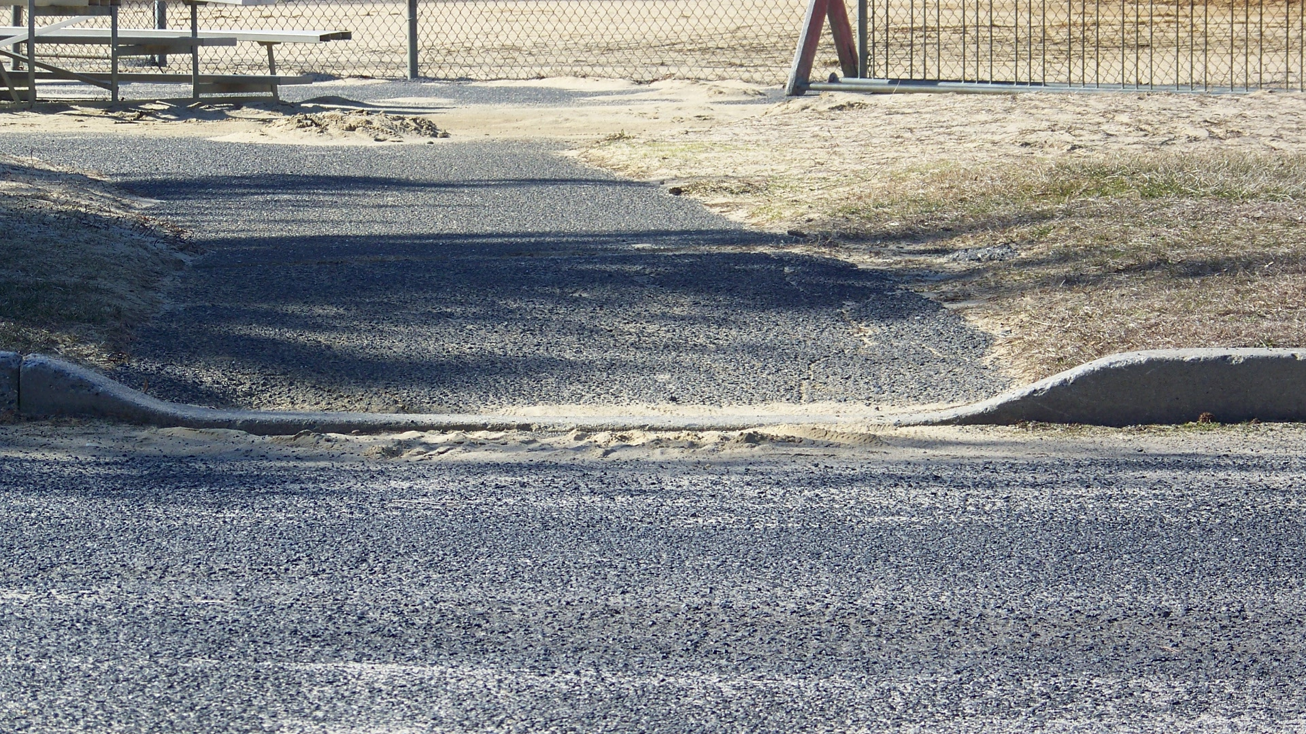
The south curb ramp serving the ball fields has an
excessive lip.

Priority Level | Cost Estimate Totals
Low’s | $6,000
Medium’s | $8,800
High’s | $3,100
TOTAL | $17,900.00*

* Cost estimates are given as general guidance only. Actual construction costs will vary depending on availability of materials and contractors used and the type of barrier removal utilized.

