Hillside Community Center  Middletown Township (N.J.)  ADA Transition Plan
Chestnut Ave. (Leonardo) Spring 2008
Location | Identified Barrier(s) | Recommended Corrective Action  Based on ADAAG or Applicable Guideline | Priority:  L=Low  M=Medium  H=High | *Cost Estimate | Barrier Removal Target Date & Notes
EXTERIOR FEATURES
Parking | One space is signed as accessible but no “van accessible” designation exists and there is not an access aisle marked. | At least 1 accessible space shall be designated as “van accessible” and served by an access aisle at least 96” wide (4.1.2(5)(b) & 4.6.4). | H | $500
Pedestrian Paths of Travel | The curb ramp at the accessible parking has a 3” lip at the bottom and has a running slope up to 14%  The entrance door has a 1” threshold | Transitions from ramps to walks, gutters, or streets shall be flush and free of abrupt changes and slopes shall not exceed 1:12 or 8.33% (4.7.2 & 4.8.2).  Recommendation: install a parallel curb ramp as indicated in the picture.  Thresholds at doorways shall not exceed ½” beveled (4.13.8). | H  H | $700  $200
 |  | INTERIOR FEATURES
Miscellaneous Rooms and Spaces | Exit and classroom signage are not in accessible locations or formats  Class rooms have round door knobs and lack alarm notification devices. | Letters and numerals shall be raised 1/32”, upper case, sans serif or simple serif type and shall be accompanied with Grade 2 Braille. Where permanent identification is provided for rooms and spaces, signs shall be installed on the wall adjacent to the latch side of the door. Mounting height shall be 60’ above the finish floor to the centerline of the sign (4.30.4 & 4.30.6).  Handles, pulls, latches, locks, and other operating devices on accessible doors shall have a shape that is easy to grasp with one hand and does not require tight grasping, tight pinching, or twisting of the wrist to operate. At a minimum, visual signal appliances shall be provided in buildings and facilities in each of the following areas: restrooms and any other general usage areas (e.g., meeting rooms), hallways, lobbies, and any other area for common use (4.13.9 & 4.28.1). | H  H | $300  $2,500
Drinking Fountain | One lowered fountain exists and has a spout 40” high. | Where only one drinking fountain is provided on a floor there shall be a drinking fountain which is accessible to individuals who use wheelchairs and one accessible to those who have difficulty bending or stooping. Spouts shall be no higher than 36”, measured from the floor or ground surfaces to the spout outlet (4.1.3(10) & 4.15.2). | L | $700
Public Restrooms | Men’s/Women’s:  - Signage is mounted 55” high to center.  - Entrance doors require 7 lbs. force to open and have 40” maneuvering clearance depth on pull side of doors.  - Sinks have 26” knee clearance to apron, exposed drain pipes and round faucet controls.  - Mirrors are 49” high to reflective surface.  - Toilets in accessible stalls are 16” high and toilet paper dispensers are inaccurately mounted.  - The flush control in the accessible women’s stall is located on far side of toilet.  - The men’s accessible toilet stall lacks grab bars.  - The urinal in the men’s room is 25” high to rim.  - Restrooms do not have visual/audible fire alarm devices. | Mounting height shall be 60’ above the finish floor to the centerline of the sign on the wall adjacent to the latch side of door (4.30.6).  5 lbs. maximum force for interior hinged doors. Front approaches to pull side of swinging doors shall have maneuvering space that extends from the hinge side of the door, beyond the latch side of the door and 60” minimum perpendicular to the doorway (4.13.11 & Figure 25(a)).  Lavatories shall provide a clearance of at least 29” above the finish floor to the bottom of the apron. Hot water and drain pipes exposed under sinks shall be insulated or otherwise configured so as to protect against contact. Faucets shall be lever-operated, push-type, touch-type, or electronically controlled mechanisms (4.19 & 4.24).  Mirrors shall be mounted with the bottom edge of the reflecting surface no higher than 40” above the finish floor (4.19.6).  The height of water closets shall be 17” to 19”, measured to the top of the toilet seat. Toilet paper dispensers shall be below the grab bar and at least 19” above the floor and no farther than 36” from the rear wall, measured to the far side of the dispensers (4.16.5 & Figure 30(d)).  Flush controls shall be mounted on the wide side of toilet areas (4.16.5).  The rear grab bar shall be at least 36” long and the side bar shall be at least 42” long. All grab bars shall be located 33” to 36” above the finish floor to the top gripping surface. Placement of grab bars shall comply with Figure 30.  Urinals shall be stall-type or wall-hung with an elongated rim at a maximum of 17” above the finish floor. Flush controls shall be mounted no more than 44” above the finish floor (4.18.2 & 4.18.4).  At a minimum, visual signal appliances shall be provided in buildings and facilities in each of the following areas: restrooms and any other general usage areas (e.g., meeting rooms), hallways, lobbies, and any other area for common use (4.28.1). | M  M  M+  L  L+  L  H  L  H | $0  $1,800  $600  $100  $500  $300  $150  $1,500  $800

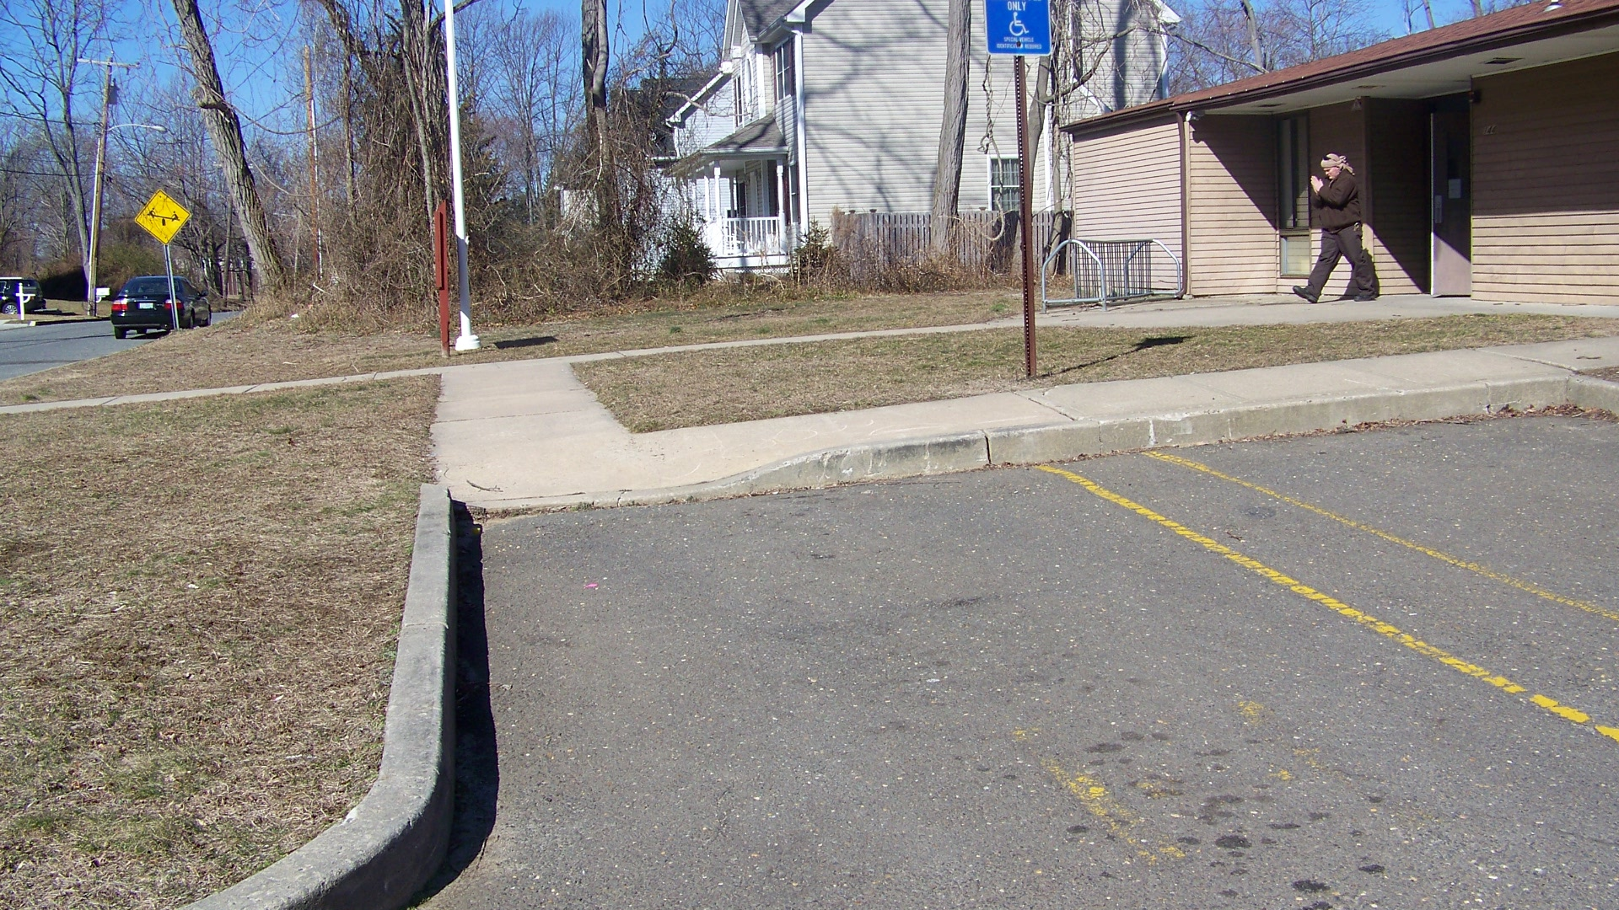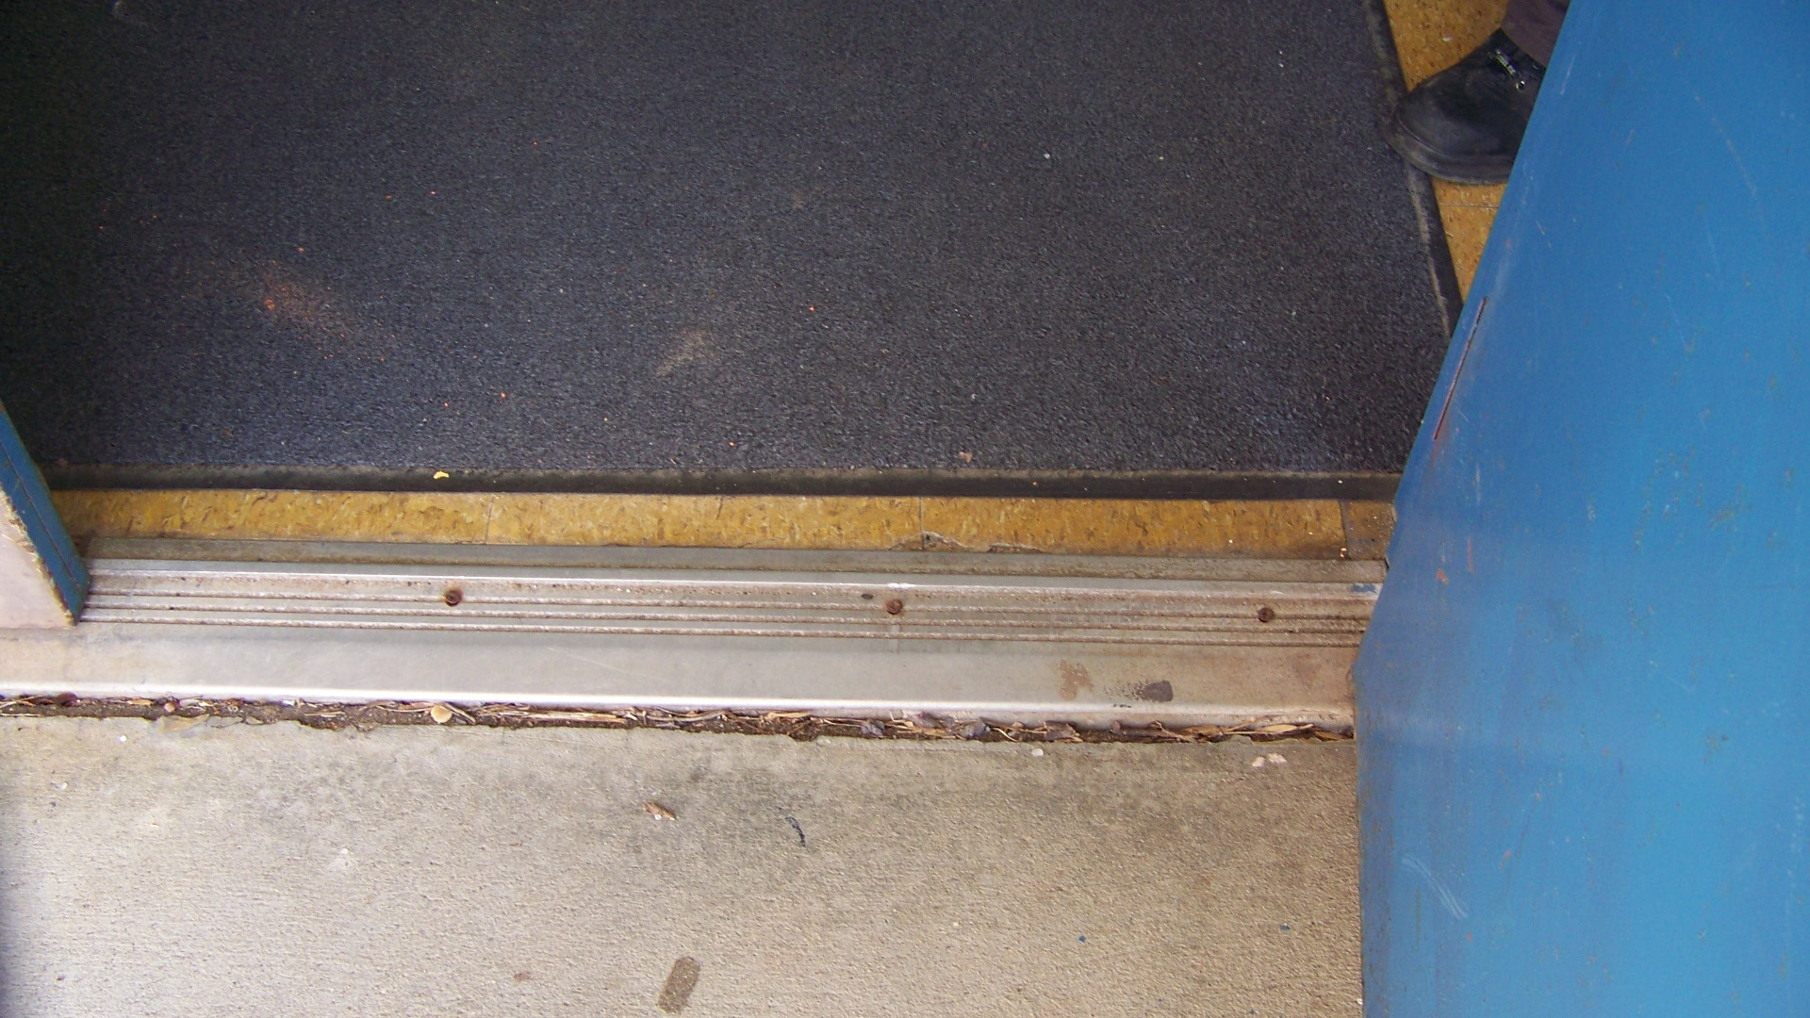
The blue circle indicates an excessive slope and lip The entrance door has an excessive threshold.
on the curb ramp. The red arrow indicates our
recommendation for placement of a parallel ramp.

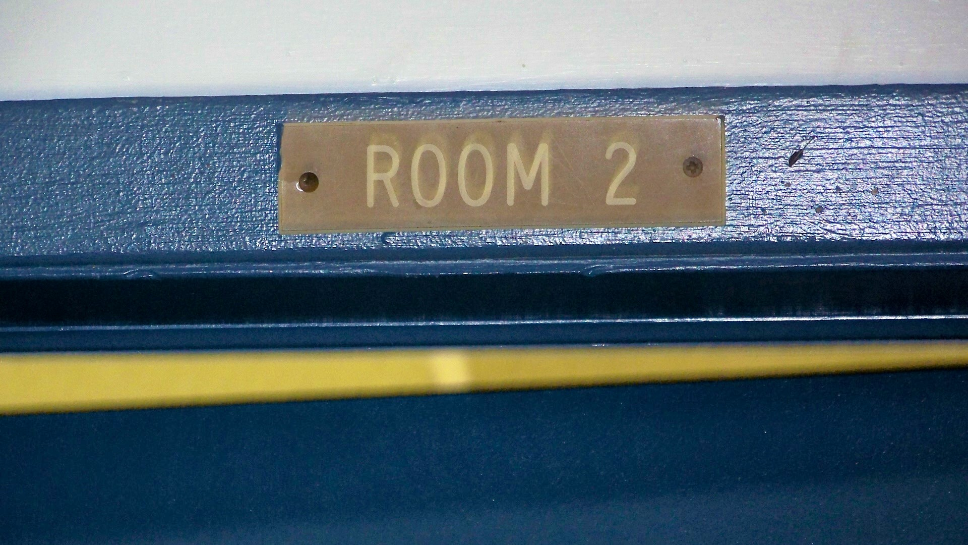
Interior rooms and spaces have signage in incorrect
locations and inaccessible formats.

Priority Level | Cost Estimate Totals
Low’s | $3,100
Medium’s | $2,400
High’s | $5,150
TOTAL | $10,650.00*

* Cost estimates are given as general guidance only. Actual construction costs will vary depending on availability of materials and contractors used and the type of barrier removal utilized.

