Bayshore Recreation Center  Middletown Township (N.J.)  ADA Transition Plan
Port Monmouth Rd. & Bray Ave. Spring 2008
Location | Identified Barrier(s) | Recommended Corrective Action  Based on ADAAG or Applicable Guideline | Priority:  L=Low  M=Medium  H=High | *Cost Estimate | Barrier Removal Target Date & Notes
EXTERIOR FEATURES
Parking | Two spaces are signed as accessible but no “van accessible” designation exists and there is not an access aisle marked. | At least 1 accessible space shall be designated as “van accessible” and served by an access aisle at least 96” wide. Two spaces may share a common access aisle (4.1.2(5)(b) & 4.6). | H | $500
Picnic Areas | The route to picnic tables is rough and uneven grass. | At least one accessible route shall connect accessible buildings, facilities, elements, and spaces that are on the same site. Ground and floor surfaces along accessible routes shall be stable, firm, slip-resistant and free of abrupt changes in level (4.3.2).  Recommendation: install at least one accessible picnic table and barbecue grill that are connected to the shelter on an accessible route. | M- | $1,000
Play Area | The play equipment surface is engineered wood chips. | Recommendation: this material has been generally accepted as “ADA compliant”, however, to maintain an adequate firm and level surface free of thresholds, this surface must be constantly maintained. We recommend using a rubber or corked surface. There are no ADA enforceable standards for playground areas, only guidelines at the present time; however, program access must still be met. | L+ | $3,000
Entrance | The exterior maneuvering clearance slopes up to 7% at door  The entrance door hardware requires pinching of the hand to operate.  A 3” threshold exists at the entrance | The floor or ground area within the required maneuvering clearances shall be level and clear (4.13.6 & Figure 25).  Handles, pulls, latches, locks, and other operating devices on accessible doors shall have a shape that is easy to grasp with one hand and does not require tight grasping, tight pinching, or twisting of the wrist to operate (4.13.9).  Thresholds at doorways shall not exceed ½” beveled (4.13.8). | H  H  H | $2,500  $50  $200
 |  | INTERIOR FEATURES
Miscellaneous Rooms and Spaces | Exit signs are not in accessible locations or formats.  A pre-school class meets on the second floor, which is only accessible via stairs. | Letters and numerals shall be raised 1/32”, upper case, sans serif or simple serif type and shall be accompanied with Grade 2 Braille. Where permanent identification is provided for rooms and spaces, signs shall be installed on the wall adjacent to the latch side of the door. Mounting height shall be 60’ above the finish floor to the centerline of the sign (4.30.4 & 4.30.6).  Recommendation: if modifying the second floor for ADA compliance is not structurally practical/feasible, we recommend re-locating this program as needed to an accessible location. | H  M+ | $150  --
Gymnasium | The entrance door is 29” wide (double doors).  No alarm notification devices exist. | Doorways shall have a minimum clear opening of 32” with the door open 90 degrees, measured between the face of the door and the opposite stop (4.13.5).  At a minimum, visual signal appliances shall be provided in buildings and facilities in each of the following areas: restrooms and any other general usage areas (e.g., meeting rooms), hallways, lobbies, and any other area for common use (4.28.1). | L  H | $700  $500
Public Restrooms | The route to the restrooms crosses a 2” threshold  Men’s/Women’s:  - Signage is mounted 54” high to center on the hinge side of doors.  - Entrance doors require 7 lbs. force to open.  - Sinks have 27” knee clearance to apron, exposed drain pipes and round faucet controls.  - Mirrors are 44” high to reflective surface.  - “Accessible” toilet stalls are not accessible due to numerous barriers including: narrow widths and depths, inward swinging doors, inadequate grab bar placement, etc.  - The urinal in the men’s room is 25” high to rim.  - Restrooms do not have visual/audible fire alarm devices. | Changes in level up to ¼” may be vertical and without edge treatment. Changes in level between ¼” and ½” shall be beveled with a slope no greater than 1:2. Changes in level greater than ½” shall be accomplished by means of a ramp (4.5.2).  Mounting height shall be 60’ above the finish floor to the centerline of the sign on the wall adjacent to the latch side of door (4.30.6).  5 lbs. maximum force for interior hinged doors (4.13.11).  Lavatories shall provide a clearance of at least 29” above the finish floor to the bottom of the apron. Hot water and drain pipes exposed under sinks shall be insulated or otherwise configured so as to protect against contact. Faucets shall be lever-operated, push-type, touch-type, or electronically controlled mechanisms (4.19 & 4.24).  Mirrors shall be mounted with the bottom edge of the reflecting surface no higher than 40” above the finish floor (4.19.6).  Recommendations: if it is not structurally practical/feasible to install an accessible toilet stall per 4.17 in each restroom, we recommend installing an accessible “unisex” restroom in an alternate location. Inaccessible restrooms should have signage that indicate the location of the nearest accessible restroom.  Urinals shall be stall-type or wall-hung with an elongated rim at a maximum of 17” above the finish floor. Flush controls shall be mounted no more than 44” above the finish floor (4.18.2 & 4.18.4).  At a minimum, visual signal appliances shall be provided in buildings and facilities in each of the following areas: restrooms and any other general usage areas (e.g., meeting rooms), hallways, lobbies, and any other area for common use (4.28.1). | M+  H  M  M+  L  M  L  H | $200  $200  $0  $600  $100  $8,000*  $1,500  $1,000

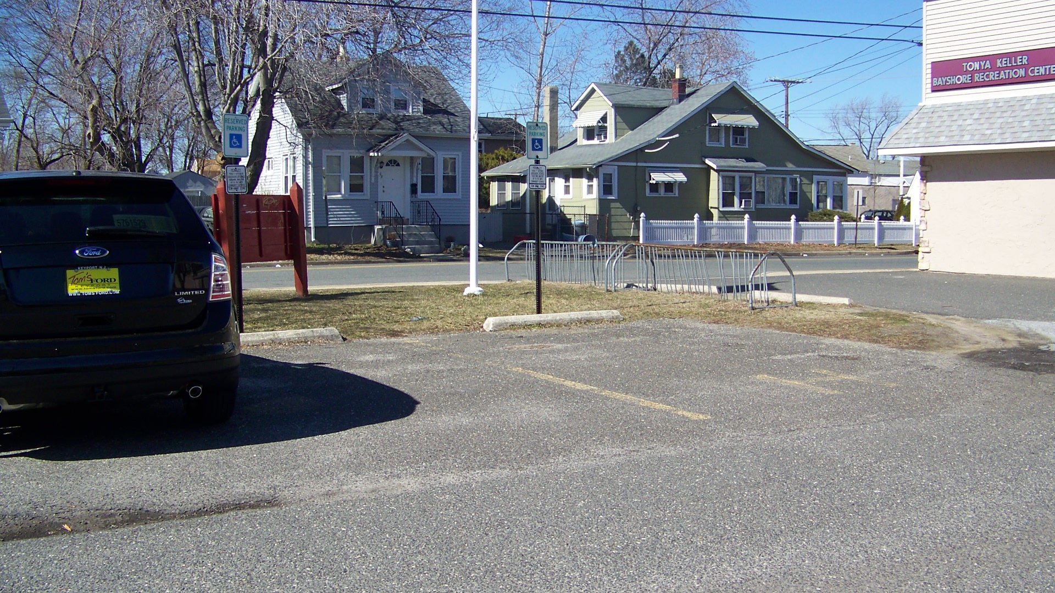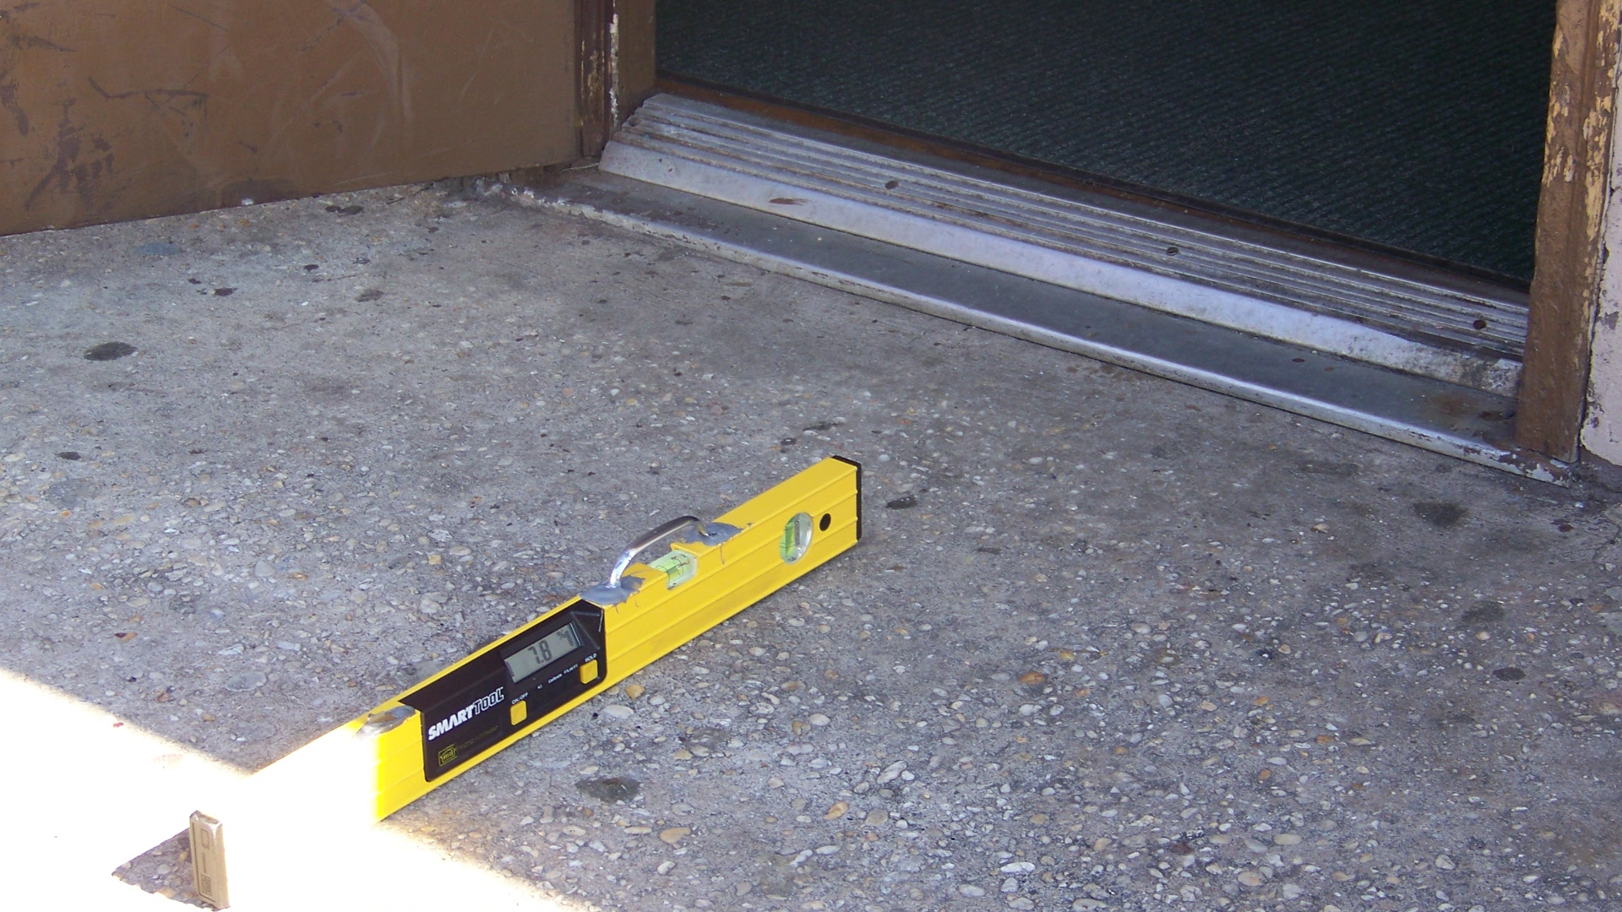
Accessible parking spaces lack “van accessible” There is an excessive slope on the exterior of the
designation and access aisles. entrance door. An excessive threshold also exists.

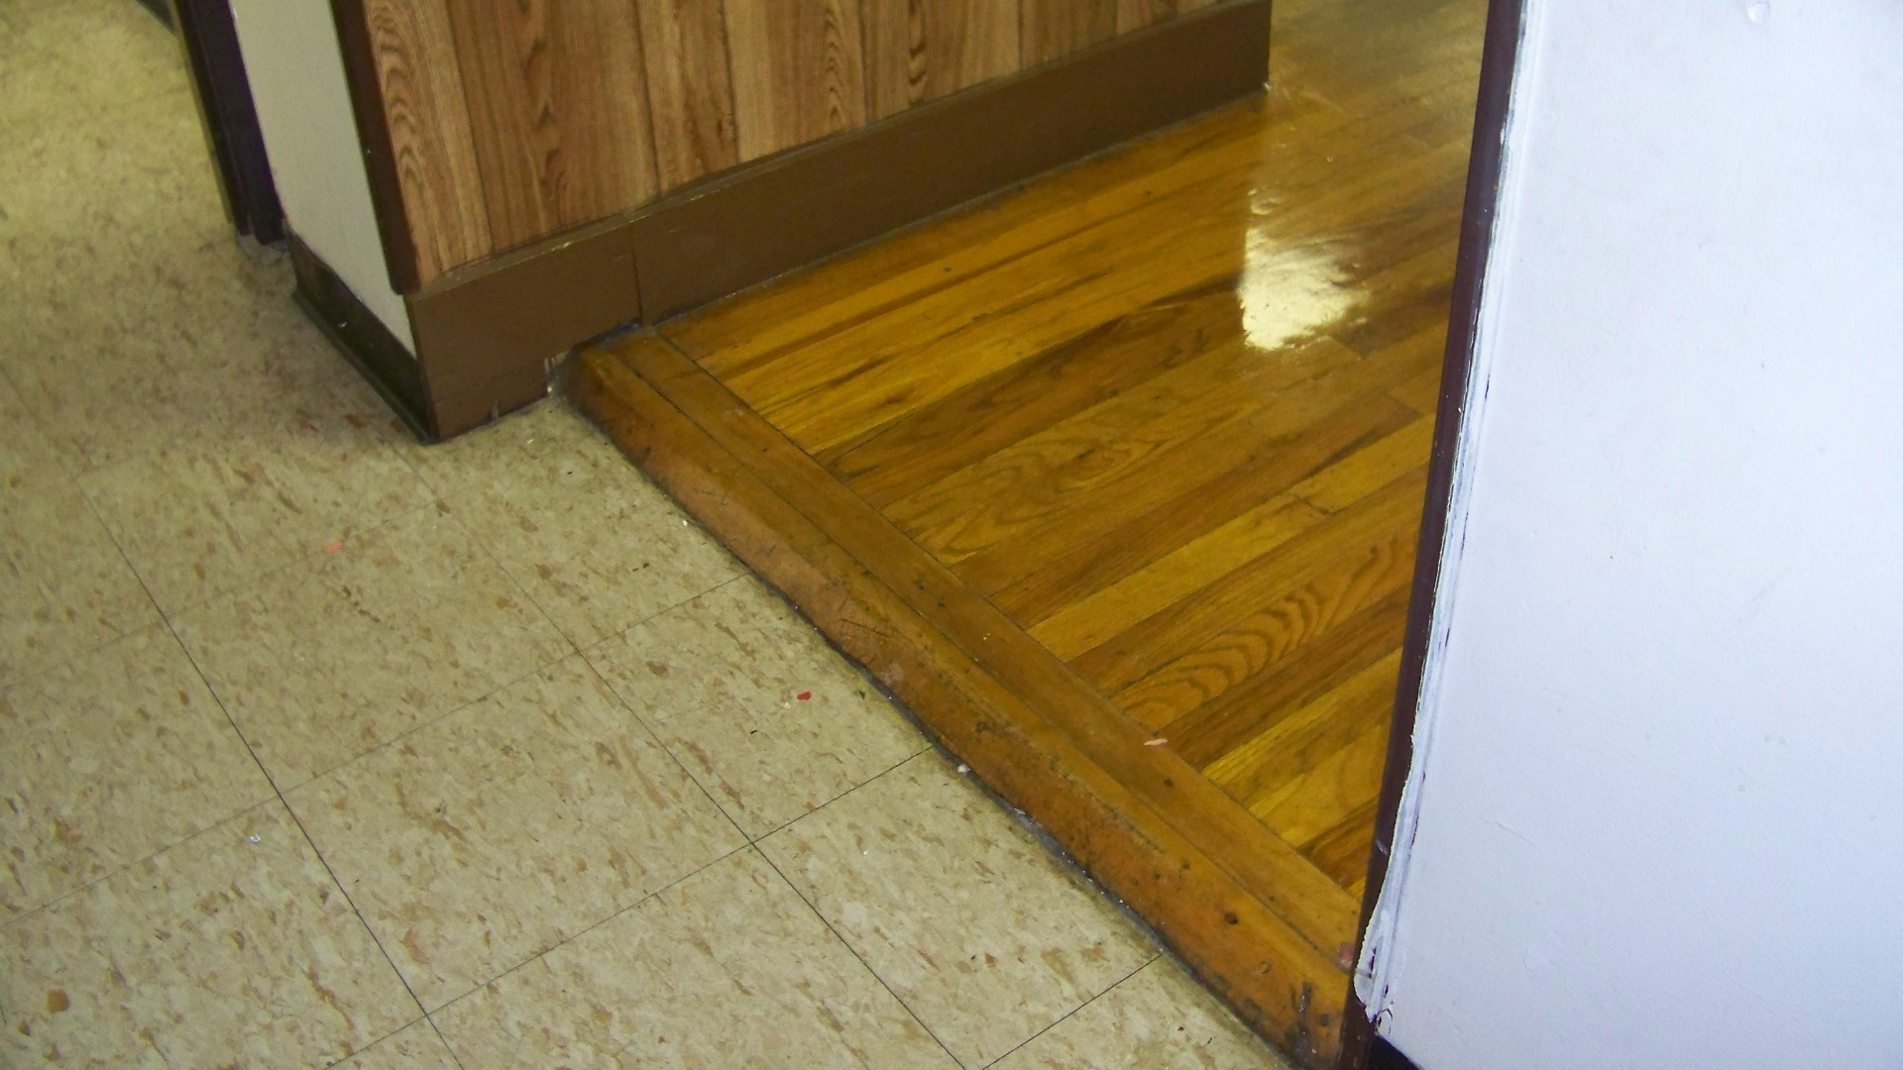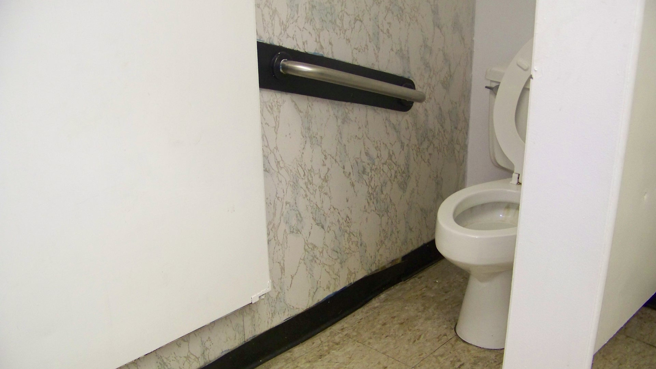
The route to the restrooms has an excessive threshold. Toilet stalls are too narrow and short and have
inadequate grab bars.

Priority Level | Cost Estimate Totals
Low’s | $5,300
Medium’s | $9,800
High’s | $5,100
TOTAL | $20,200.00*

* Cost estimates are given as general guidance only. Actual construction costs will vary depending on availability of materials and contractors used and the type of barrier removal utilized.

